**How do I download submitted coursework?**

The two main routes to online coursework submission each have a different mechanism for downloading the submitted files.

 **Standard “Upload a single file” assignment**

If you created one of these assignments, it will have a  icon. The files are uploaded to Learn and marks and feedback are found there too. When, as tutor, you access the assignment you get a link to “View the 199 submitted assignments”, and clicking this displays a page showing a tabulated list of submissions. Top right of the table (but you may have to scroll it sideways to see it) is a “Download all assignments as a zip” link. Click this and the zip file is generated (which may take a minute or two) and downloaded. Unzip it on your PC into a folder created for the purpose.

 **TurnItIn Assignment**

More and more departments are using this form of online submission because it automatically submits everything to TurnItIn for Originality Checking, and it makes the GradeMark online marking tool available. These assignments have the TurnItIn logo as their icon: 

As tutor, when you click on the assignment link, you are presented with a 4-tab page. The first tab – “Summary” should contain the submission dates, and three familiar icons in the Export section.:

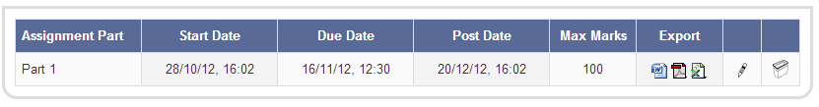

The Word icon allows you to download a zip file containing the original documents that were submitted.

The Acrobat icon in the middle downloads the PDF versions of the files. Maybe useful for sending to an External Examiner or somebody else who should not have write access to the submissions.

The Excel icon on the right downloads a spreadsheet of the submissions, showing:

* Student’s name
* Submission title
* Date and time of submission
* Mark awarded in GradeMark (if any)
* Originality score, categorised by type of source