How do I give feedback to an online assignment?
Each of the two assignment types has its own feedback mechanism

- Delivering feedback for a standard “Upload a single file” assignment
The tabulated submissions list has a Grading button which leads to a screen where a mark can be assigned; bespoke text comments can be added and one or more files can be uploaded.
One file could contain your generic comments applicable to the whole class (“On the whole most of you answered Part A well but a lot of you had problems with Part B…”).
A second file could be the student’s original file, saved by you with Track Changes enabled so your comments are superimposed on the student’s work, in context. The student can then see your comments in context.

- Delivering feedback for a TurnItIn assignment, marked with GradeMark
The Submission Inbox tab lists every student’s submission, the date/time it was submitted and its Originality score – exoressed as a percentage of the text that matches other sources. It also has a link to GradeMark (the red apple icon).
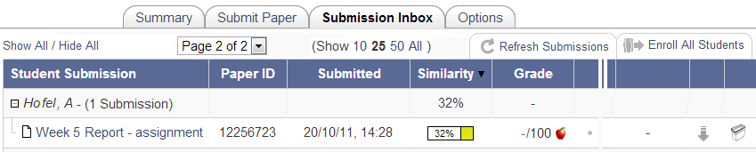
The student’s Inbox only shows their row of the table, of course, but they will be able to access GradeMark by clicking the apple, just as you can.
Once in GradeMark, the students can see your marginal comments, pop-up comments and summative remarks, overlaid on their coursework. If they want a paper copy, they can download a PDF version complete with the comments. They will be able to access the online version for as long as they can access Learn or its archived versions (e.g. Learn11 or Learn10)

