Changes to TurnItIn for 2014-15
The underlying Moodle that runs Learn will be upgraded to version 2.6 in July 2014. At the same time, the TurnItIn plug-in will be changed to version 2 of the Moodle Direct, and all TurnItIn activity will go through a new account. Tutors who are familiar with the old TurnItIn system on Learn will find everything is still there, but it looks rather different.
A short PowerPoint presentation describing what students need to know can be made available for all staff to download and add to their slides.
The new assignment activity is created in exactly the same way as the previous version, but this one is called ‘TurnItIn Assignment 2’ .

You may be asked to agree to their new User Agreement.
Click the Agree button and move on.

 | The new plugin is better at telling you what is going on, which should prevent multiple submissions.
Every submission gets a digital receipt, to confirm that it has arrived OK. | 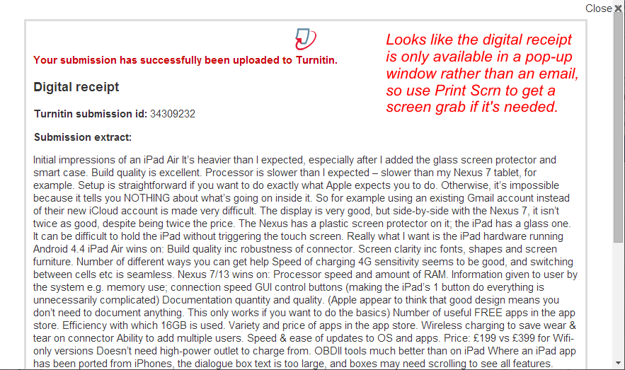

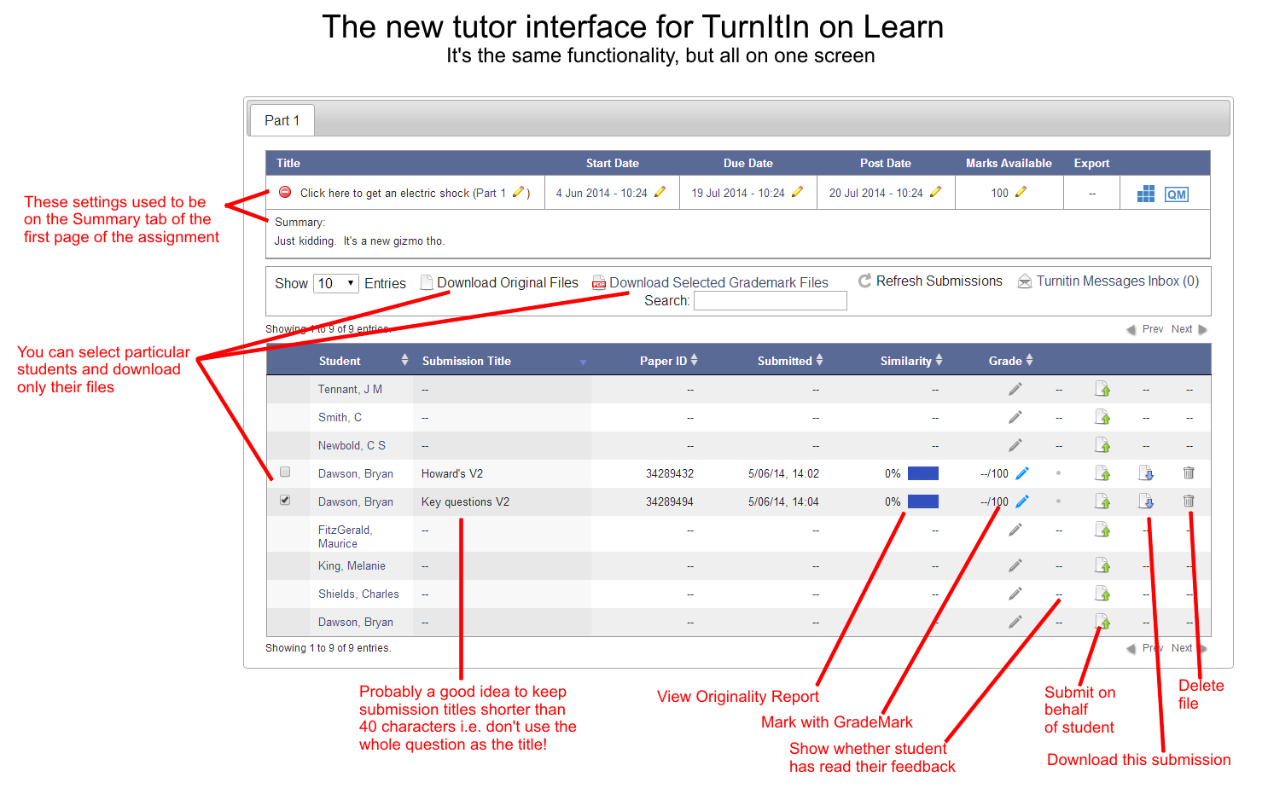
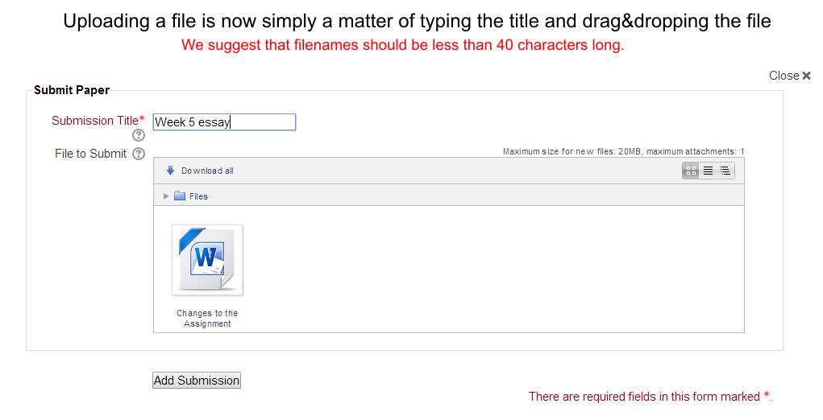
TurnItIn can now accept any file type, up to 20 Mbytes in size, but only Word (.doc, .docx), PowerPoint (.ppt, .pptx), Excel (.xls, .xlsx), WordPerfect (.wps), Adobe Acrobat (.pdf), HTML (.htm, .html) Text (.txt) and Rich Text Format (.rtf) can be checked for originality. Excel and Acrobat files are only checked for text – numbers, formulae, macros and images are ignored.

